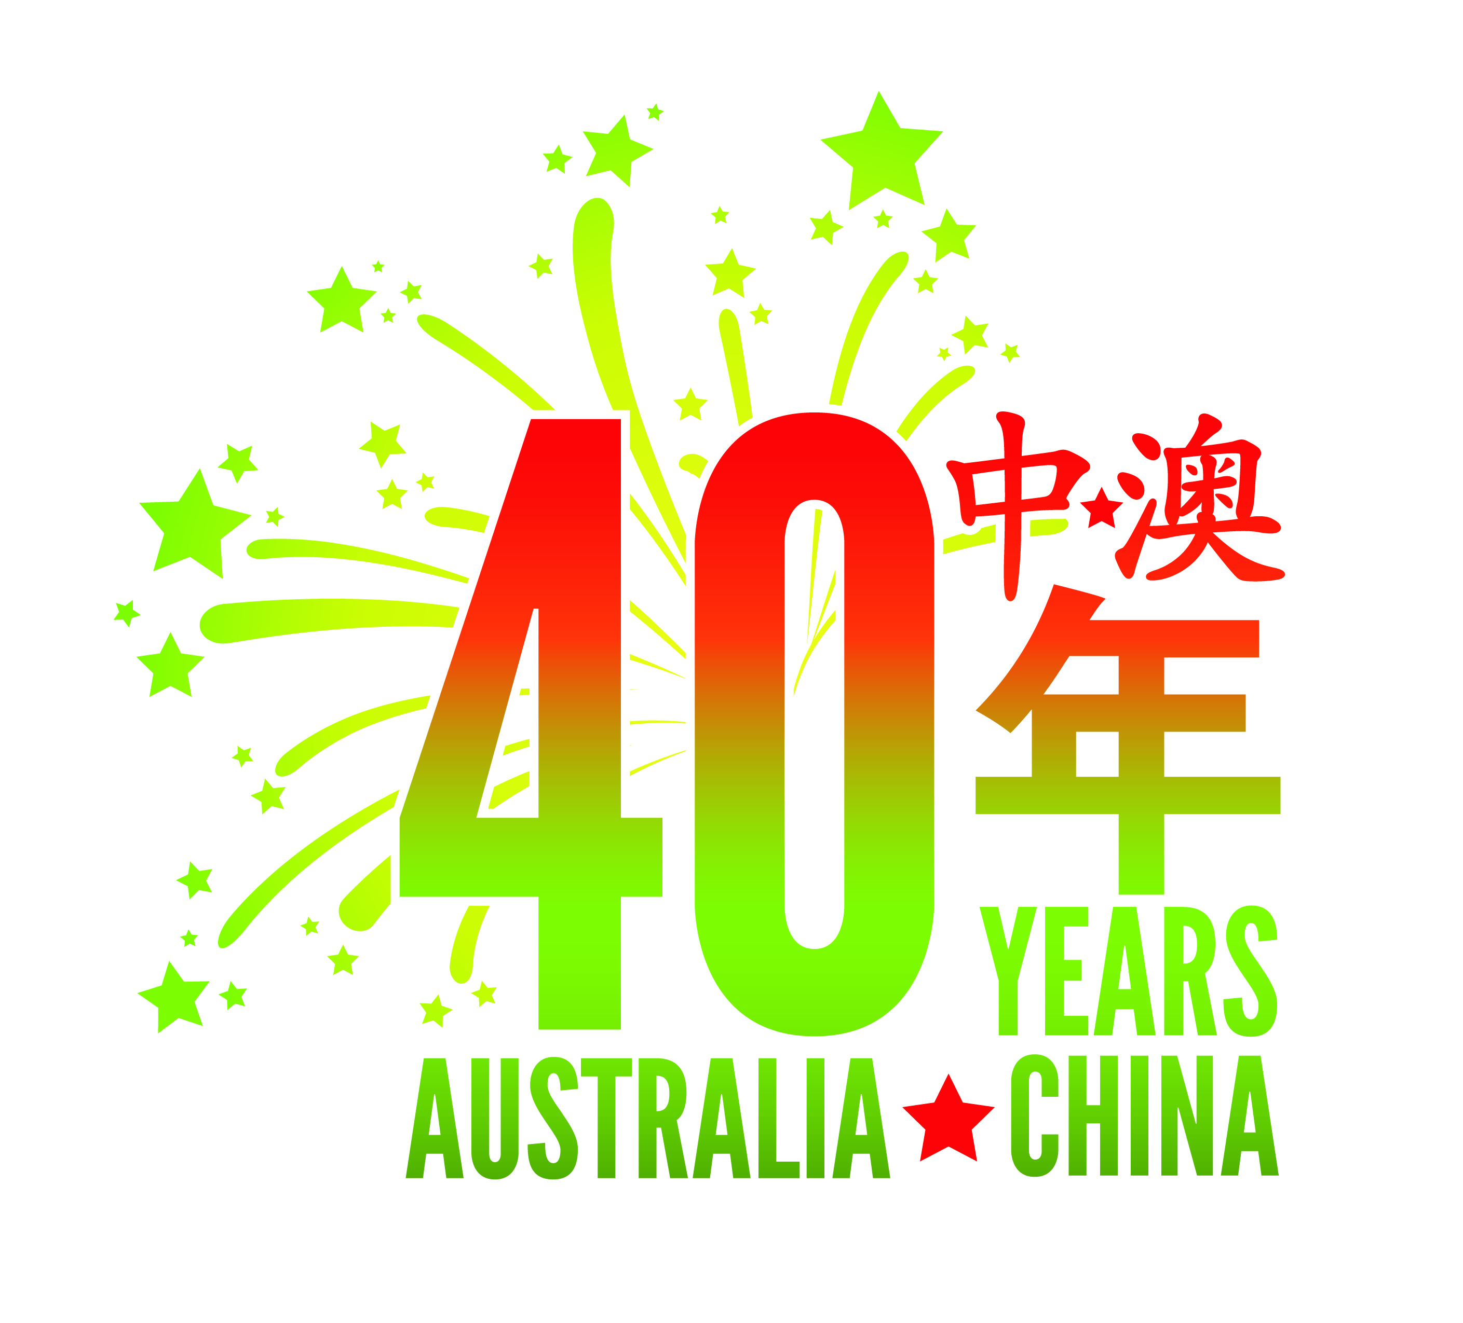

Celebrating the 40th Anniversary of Australia-China Diplomatic Relations in 2012

庆祝中国-澳大利亚建交40周年

2012 - 40th Anniversary Program of Events and Initiatives (Selected Events)

February 2012 | Visit by Aust Science Minister | Affirming that science and research are a key area for bilateral cooperation | Beijing
March 2012 | Australian Writers Week | Show casing in China Australia’s emerging and established writers | Beijing
April 2012 | International Women’s Day Ambassador’s Breakfast | Marking the economic, political and social achievements of women | Beijing
April 2012 | Aust-China Film Industry Forum | Reinvigorating the relationships between the film industries in Australia and China | Beijing
April 2012 | Visit by Aust Minister for Climate Change | Co-hosting the Australia China Ministerial Dialogue on Climate Change | Beijing
April 2012 | Inaugural Australian Alumni Careers Fair | Held in conjunction with www.zhaopin.com profiling the quality and skills of Australian-educated graduates | Shanghai
April 2012 | Wine Australia’s ‘Taste Discovery’ Tour | Linking Australian wineries with China’s wine networks | Dalian, Chengdu, Wuhan
May 2012 | Visit by Aust Minister for Foreign Affairs | Launching Australia’s 40th Anniversary Celebrations | Beijing  Shenyang
May 2012 | HMAS Ballarat port call | The Royal Australian Navy engaging with the Chinese people | Shanghai
May 2012 | China International Fair for Trade in Services | Incorporating Australia Feature Day and the inaugural Australia China Services Sector Promotion Forum | Beijing
May 2012 | Visit by Australian Minister for Trade and Competitiveness | Representing Australia at CIFTIS | Beijing
May  August  September 2012 | Australia China Business Week in  Melbourne  Sydney and  Shanghai | Hosted by the Australian Business Forum - expanding business ties | Melbourne  Sydney  Shanghai
June 2012 | Launch of Australia’s new tourism campaign | Launched in China to reflect the exponential growth in visits between Australia and China | Shanghai
June 2012 | Visit by Australian Minister for Tourism | Launching the "There's Nothing Like Australia" campaign | Shanghai
June 2012 | Visit by Australian Defence Minister | Inaugural Defence Ministers Dialogue | Beijing  Guangzhou  Zhanjiang
June 2012 | The Australian Arbitration Option | A forum showcasing Australia as a centre for international arbitration | Beijing  Shanghai
June 2012 | Book Launch by the China Studies Centre, University of Sydney | ‘Australia and China at 40’ | Sydney
June 2012 | China Australia Media Forum | Examining the role of the media in enhancing understanding and cooperation in economics and trade | Guangzhou
July 2012 | The Biennial Australia Studies Conference | Hosted by Xihua University, Chengdu and with support from the Australia- China Council | Chengdu
July 2012 | Visit by Australian Deputy Prime Minister & Treasurer | Leading a delegation to the Australia China Economic and Trade Cooperation Forum | Beijing
July 2012 | Gala Dinner celebrating the 40th Anniversary | Hosted by the Australian Deputy Prime Minister & Treasurer | Beijing
July 2012 | Artlink Magazine Special Edition | Experiencing Australian indigenous art in Chinese through a special bilingual edition
July 2012 | Australia Week | Sharing all the best Australia has to offer China | Kunming
August 2012 | Australia Week | Sharing all the best Australia has to offer China | Shenyang
August 2012 | Parliamentary Delegation to China | Enhancing bilateral linkages | Various cities
August 2012 | MLA Red Majesty Chinese Chef Launch | Teaming Asia's finest chefs with Australia's finest beef and lamb | Beijing
August 2012 | Young Persons Essay Competition (Uni of Sydney China Studies Center) | Encouraging engagement between young Australians and Chinese | Online
August 2012 | Meeting Halfway Art Exhibition | Two northern Chinese and two Australians showcase their work in Guangzhou (and later Melbourne) | Guangzhou/  Melbourne
September 2012 | Australia Week | Sharing all the best Australia has to offer China | Wuhan
September 2012 | The Australia-China Futures Dialogues - Leader’s Lecture featuring Australia’s Ambassador to China | A Griffith University initiative in collaboration with Peking University and the Queensland Government examining the future evolution of the Asia Pacific region | Beijing
September 2012 | Australia China Alumni Awards | Recognizing the wide-ranging achievements of graduates of Australian universities that are currently based in China, both local and expatriate | Shanghai
September 2012 | Sydney China Business Forum | High level discussion of the outlook for Australian-Chinese Energy Cooperation | Sydney
September 2012 | Australia in China’s Century Conference | Hosted by The Australian and the Wall Street Journal | Sydney
September 2012 | Australia-China Science and Research Knowledge Exchange Symposium | Facilitating dialogue and celebrating achievement in research collaboration between Australia and China | Melbourne
October 2012 | Australia Week | Sharing all the best Australia has to offer China | Nanjing
October 2012 | Frontiers of Knowledge Symposium: Australia-China and Beyond to 2020 | Discussing the themes of vital importance in the future of Australia China bilateral relations | Shanghai
October 2012 | Skills for Sustainability Conference | Bringing together TAFE Directors Australia and the Chinese Education Association for International Exchange | Beijing
October 2012 | Australia-China Business Council (WA) : 2012 Education Forum | Sharing experiences and planning for progressing Chinese language and cultural training in WA | Perth
October 2012 | ACBC China National Day | Celebrating the 40th Anniversary | Perth
October 2012 | Book Launch by the China Studies Centre, University of Sydney | ‘Australia and China at 40’ | Beijing
October 2012 | Sydney Symphony Orchestra China Tour | Bringing some of Australia’s finest orchestral music to China | Multiple cities
October 2012 | Australia China Youth Dialogue | Promoting frequent and meaningful engagement between young adults in China and Australia who are interested in furthering Australia-China relations | TBC
October 2012 | Australia China Quarterly Special Edition | Highlighting the 40th Anniversary | Australia  China
November 2012 | Australia China University Leaders Forum | Showcasing successful collaboration in tertiary education | Canberra
November 2012 | Inaugural Australian Resources Conference and Trade Show
November-December 2012 | Exhibition of Australian Contemporary Photography | Remembering Prime Minister Whitlam’s historic visit to China in 1973 hosted by the Australian Centre for Photography and China’s National Art Museum | Beijing
December 2012 | Robogals Tour of China | Young Australian of the Year visits Chinese universities highlighting Australia’s science, technology and entrepreneurial talents | Multiple cities
December | Oral History Project celebrating the 40th Anniversary | ‘Beyond the Cables: Australian Ambassadors to China 1972-2012’ - A Joint Initiative of the National Library of Australia and the Australia-China Council
December | Commemoration of the Anniversary | Gala Dinner hosted by Prime Minister Gillard – Australian Parliament House, Canberra, 12 December 2012  Gala Dinner hosted by Chinese People’s Association for Friendship with Foreign Countries – Great Hall of the People, Beijing, 14 December 2012 | Canberra  Beijing

